Customer Shopping Behaviour Dashboard – Project Overview

1. Project Objective
To analyze customer shopping behavior by cleaning and processing raw CSV data using Python, storing it in PostgreSQL, performing SQL-based data analysis, and visualizing insights through an interactive Power BI dashboard.

2. Tools and Technologies Used
- Python (Pandas, NumPy, SQLAlchemy, Psycopg2)
- PostgreSQL (for data storage and SQL analytics)
- Power BI (for data visualization and dashboard creation)
- Jupyter Notebook (for coding and analysis)

🧱 3. Data Preparation in Python

Step 1: Import Required Libraries
import pandas as pd
import numpy as np
from sqlalchemy import create_engine

Step 2: Import the CSV File
# Load CSV file
df = pd.read_csv('customer_shopping_behavior.csv')

# Display all data
print(df.head())
print(df.info())

Step 3: Data Cleaning and Preprocessing
Performed the following tasks to ensure data quality and consistency:

✅ Handle Missing and Erroneous Data
# Check for missing values
print(df.isnull().sum())

# Fill or drop missing values
df = df.dropna() # or df.fillna(method='ffill')

✅ Rename Columns to Standard Format
# Rename columns for better readability
df.rename(columns={
'Customer ID': 'customer_id',
'Gender': 'gender',
'Purchase Amount (USD)': 'purchase_amount_usd',
'Category': 'category',
'Discount (%)': 'discount_percent'
}, inplace=True)

✅ Rearrange Columns for Better View
df = df[['customer_id', 'gender', 'category', 'purchase_amount_usd', 'discount_percent']]

4. Database Integration (PostgreSQL)

Step 1: Install PostgreSQL and Required Libraries
pip install psycopg2
pip install sqlalchemy

Step 2: Connect to PostgreSQL in Jupyter Notebook
from sqlalchemy import create_engine

username = 'postgres'
password = 'root'
host = 'localhost'
port = '5432'
database = 'customer'

# Create database engine
engine = create_engine(f'postgresql+psycopg2://{username}:{password}@{host}:{port}/{database}')

Step 3: Upload Cleaned Data to PostgreSQL
# Load DataFrame into PostgreSQL
df.to_sql('customer_behavior', engine, index=False, if_exists='replace')
print("Data uploaded successfully!")

5. SQL-Based Data Analysis
Performed various analytical queries to extract useful business insights.
- Revenue by Gender

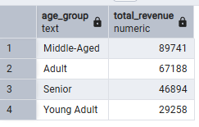
- High-Spending Discount Users

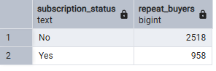
- Customers Who Buy Repeatedly

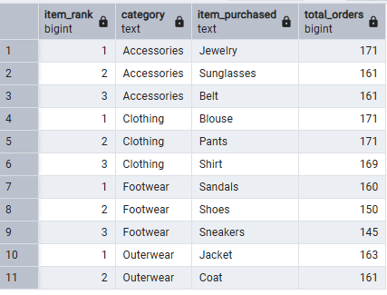

4. Top 3 Most Purchased Products

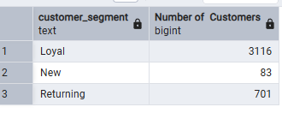
- Customer Segmentation (New, Returning, Loyal)

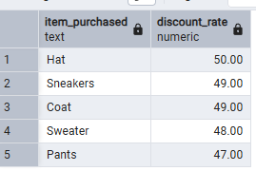
- Top 5 Products by Revenue Percentage

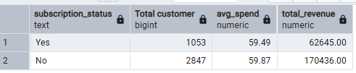
- Subscribed More Customers and Average Revenue

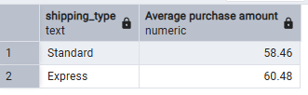
- Customers Who Used Discount

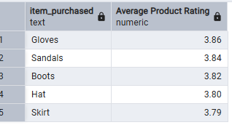
- Revenue by Gender (Male vs Female)

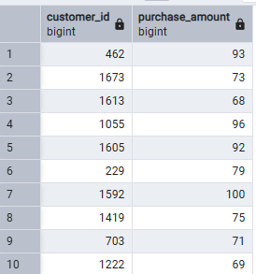

- High Spending Loyal Customers

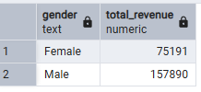

📈 6. Power BI Dashboard Creation

Key Steps:
- Connected Power BI to PostgreSQL database.
- Imported the customer_behavior table.
- Created visual KPIs and charts such as:
  - Total Revenue by Gender
  - Top Purchased Products
  - Customer Segmentation Chart
  - Discount Usage by Category
  - Average Revenue per Gender
  - Loyalty Analysis Visualization
- Designed the dashboard with slicers for gender, category, and discount filters.

💡 7. Key Insights
- Male and Female revenue comparison shows purchasing patterns differ slightly.
- “Loyal” customers contribute the highest revenue share.
- Top 3 categories dominate total purchases.
- Customers with discounts above 10% tend to spend more.
- The dashboard helps identify high-value segments for marketing.

🏁 8. Project Outcome
Successfully built a complete end-to-end data analytics workflow:
- Python for data cleaning and preprocessing
- PostgreSQL for data storage and SQL analytics
- Power BI for data visualization and insights

Insightful Dashboard
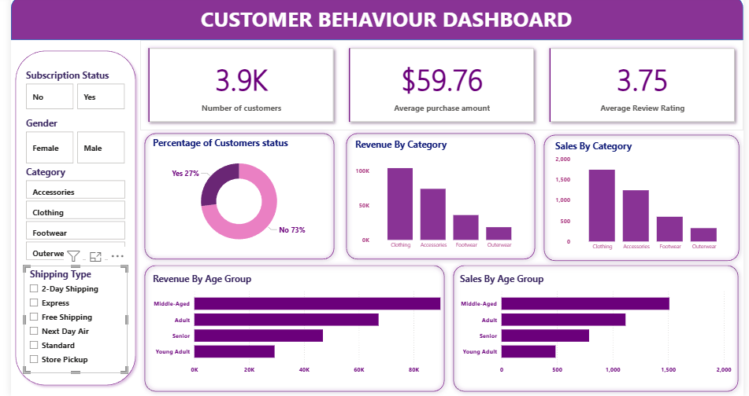

💼 9. Business Recommendations
Based on the analysis and insights derived from the Customer Shopping Behaviour Dashboard, the following recommendations can help improve sales performance, customer retention, and marketing strategies:

🔹 1. Focus on Loyal Customers
- Insight: Loyal customers generate the highest portion of total revenue.
- Recommendation:
  - Introduce exclusive loyalty programs or tier-based rewards to retain them.
  - Offer early access to new product launches and personalized discounts.

🔹 2. Improve Retention of New and Returning Customers
- Insight: A significant number of customers fall into the “New” and “Returning” categories.
- Recommendation:
  - Send follow-up emails or personalized product suggestions to re-engage them.
  - Provide first-purchase discounts or combo offers to convert new users into loyal ones.

🔹 3. Optimize Discounts for High-Spending Users
- Insight: Users with discounts above 10% tend to spend more.
- Recommendation:
  - Implement targeted discount campaigns focusing on high-value customers.
  - Use predictive models to identify customers likely to respond positively to discounts.

🔹 4. Focus on Top Performing Product Categories
- Insight: Top 3 categories generate the majority of total purchases.
- Recommendation:
  - Prioritize inventory management and marketing budgets for these categories.
  - Introduce cross-selling strategies combining high-performing and underperforming products.

🔹 5. Gender-Based Marketing Campaigns
- Insight: Revenue patterns differ slightly between male and female customers.
- Recommendation:
  - Use segmented marketing campaigns — customize product recommendations based on gender preferences.
  - Create targeted advertisements on platforms where each gender segment is more active.

🔹 6. Enhance Customer Experience
- Insight: A well-segmented customer base allows for personalized marketing.
- Recommendation:
  - Improve the customer journey by offering recommendations based on browsing and purchase history.
  - Collect customer feedback regularly to identify improvement areas.

🔹 7. Subscription and Engagement Programs
- Insight: Subscription-based customers have higher average revenue.
- Recommendation:
  - Encourage subscriptions through special perks such as free delivery or members-only offers.
  - Use data to predict churn and proactively offer retention benefits.

🔹 8. Revenue Growth Strategy
- Insight: High discounts drive immediate sales but might reduce long-term profit margins.
- Recommendation:
  - Conduct A/B testing on discount levels to find the optimal balance.
  - Focus on upselling and bundle offers rather than blanket discounts.

🔹 9. Predictive Insights for Future Strategy
- Recommendation:
  - Implement machine learning models to predict future buying trends.
  - Automate real-time dashboards to monitor customer behavior continuously.

🔹 10. Power BI Dashboard Utilization
- Recommendation:
  - Use the dashboard as a decision-making tool during marketing or pricing meetings.
  - Schedule automated data refreshes to ensure updated insights for management.

